**PROGRESS REPORT**

*For*

INDIVIDULA RESEARCH PROJECT ELEE-1166)

**3-POLE DUAL-BAND BANDPASS FILTER FOR WIMAX APPLIACTIONS**

*Written by* **-**Siddiqui Anwar Mohammed (001079524)

*Supervised by* **–** DR. Augustine O. Nwajana

*Managed by*- DR. Yehdego Habtay

*University of Greenwich*

Department of Engineering and science

**Signed statement of Originality**

I hereby conclude that this accommodation is my own work and to the very best of my knowledge and this work has not been submitted for any other purposes or any other degrees. I also confirm that all the materials like all sources and assistance received in preparing this thesis is acknowledged and referenced.

Siddiqui Anwar Mohammed

***Signature***

**Contents**

1. i. Introduction & Background……………………..4

ii. Aim& Objectives……………………………......5

iii. Deliverables……………………………….........6

2. Requirements \ Specifications………………………6

3. Possible Solutions…………………………………...6

4. i. Progress made against deliverables……………….7

ii. Further work to be done………………………….7

5. Implementation, Results and analysis………….......8

6. Intermediate Conclusion……………………………14

7. References…………………………………………..15

8. Gantt chart…………………………………………..16

9. Framework…………………………………………..18

**Chapter 1.i Introduction & Background**

First of all, in a Microwave system there are many components present which being amplifiers, filters, antennas etc. out of which the filters are very significant. These filters are basically a two port network very much capable of passing all the transmissions of frequency signals over a pass band and attenuating all the other signals which are over stop-band [1]. Lately, there has been developing enthusiasm for the plan of latent microwave channels. This intrigue is progressively significant with regards to the plan of multi-band channels. Dual band bandpass channel configuration is progressively significant with the ongoing quick development, improvement, what's more, progress in multi-band remote correspondence frameworks. Dual band bandpass channels are additionally valuable for separating a little area of a frequency spectrum inside a wider frequency spectrum [2]. In this paper a design of dual-band bandpass filter will be presented using low-pass to j-inverter conversions. Further work of implementing the Micro-strip [3] [4] for the presented dual-band bandpass filter will be presented. Micro-strip comes under the planar technology which is the major aspect in the microwave field.

A channel, otherwise called bandpass channel (BPF) passes frequencies inside a single band furthermore, attenuates every other signal frequencies outside the band this kind of channel is broadly utilized as the structure hinder in the structure of complex and multi-port circuits and frameworks. A portion of the more mind boggling gadgets that can be framed from BPFs incorporate sifting reception antennas [5], multi-band channels, separating power dividers, diplexers [6], and so on. Signal segments between a lower recurrence cut off, f1 and an upper recurrence limit, f2 while lessening and dismissing all other sign segments that fall outside the f1 and f2 band. A bandpass channel can be shaped by joining a low-pass channel with a high pass channel. Bandpass channels are generally utilized in radio recurrence (RF) front finish of cell radio base station handsets. Its fundamental capacity in the transmitter is to restrict the data transmission of the yield sign to the band allotted for the transmission. By this, the transmitter is kept from meddling with different stations. In the recipient, a bandpass channel licenses signals inside a specific band of frequencies to be gotten and decoded, while halting signals at unwanted frequencies from overcoming. Numerous authors and publishers have published many filters implementing with various aspects like using waveguides, micro-strip, transmission lines and etc.

Manyauthors have presented and published works related to filters like using coupling capacitors, defected ground structure (DGS) [7] [8], micro-strip [9], waveguides [10], transmission lines [11], antennas [5], and many more [12] [13]. In works like coupling capacitors [14], an improved presentation ultra-wideband bandpass channel by utilizing lumped capacitors as an outside coupling to ventured impedance DGS low pass channel structure. The coupling capacitor esteem influences the execution of the channel and controls the lower cut-off frequency. When using techniques like DGS design a low pass filter [15] is proposed, designed and ground is defected or cut in a desired shape which improves its performance. The size of filter is also reduced. The method to calculate the cut-off frequency of the LPF has been developed based on the modelled equivalent inductance and capacitance, which depends on the dimension of the DGS pattern. In addition, the method to determine the size of the DGS pattern, which exactly realizes the required transformed inductance, has been proposed by curve fitting with excellent accuracy. Moving on to micro-strip a half circle micro-strip [16] low pass channel with the sharp dismissal and wide stop band has been structured. The proposed channel configuration depends on the computations of channel parameters from conventional Hi-Lo impedance strategy and is accessible in the writing of micro-strip channel.

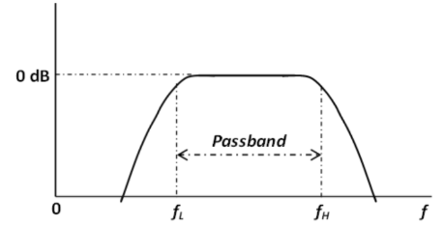 [17]

Figure 1 bandpass filter characteristics

In this paper you can see the design of a dual-band pass filter which initially is from a bandpass filter. So the characteristics of the bandpass filter are presented. In the above figure1 the band pass characteristics can be seen which shows that it allows frequencies of certain bandwidth to pass and attenuates all the other. The fL and fH can be taken for f1 and f2.

**1. ii Aim & Objectives**

The main aim of this project is to present design and implement a 3- pole dual-band bandpass filter of return loss 20 dB with a fractional bandwidth of 8% for WiMAX [18] [19] [20] applications. The theoretical design will be carried out first involving a suitable method of multiple conversions and transformations from a normalised low-pass filter to bandpass filter and then bandpass into dual-band bandpass filter. The theoretical design will then be implemented practically using the Agilent ADS (Advanced Design System) software. Some specifications will be set to achieved and the results will be achieved which will then be verified with respect to the specifications. A basic block diagram of the filter can be seen below in the figure and the circuit configurations can be seen in the implementation part further ahead in this paper.

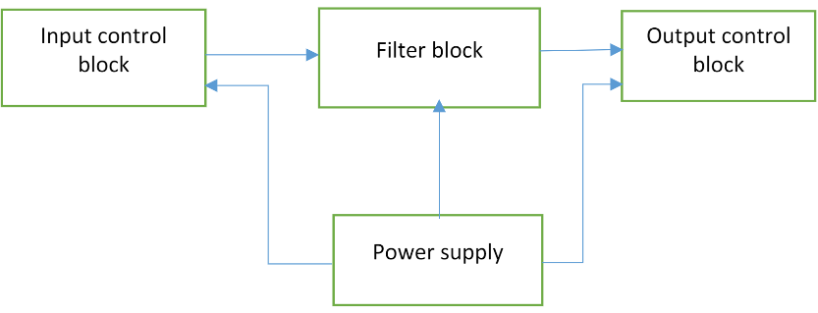

Figure 2 basic block diagram

**1.iii Deliverables**

a) Research would be carried out for design and a literature review would be written for that

Design of 3 pole dual band-pass filter in a way easy to understand.

b) A suitable method will then be selected from the literature review to proceed further in to

The design

c) Some objectives would be set to achieve as results

d) Further in to the design implementations and simulations would be performed using ADS

Software.

e) Final results would be displayed indicating the desired specifications are achieved.

**Chapter 2 .Requirements\ Specifications**

1. Centre frequency (f0 ) : 1799MHz
2. Centre frequency of upper pass-band (f2 ) : 2010MHz
3. Centre frequency of lower pass-band (f1 ) : 1610MHz
4. Return loss : 20dB
5. Fractional bandwidth (FBW) : 8%

**Chapter 3. Possible solutions**

The above specifications are very much needed for this paper for the theoretical design and transformations from bandpass to dual-band bandpass the centre frequency is calculated from the upper pass-band and lower pass-band frequency. Whereas the upper pass-band and lower pass-band frequency are the boundaries of this filter between which the results are obtained. The fractional Bandwidth is also used for theoretical design and return loss is the criteria which is observed in detail to verify the results. The results obtained must be equal to 20dB for the filter to be exceptional.

**Chapter 4.i Progress made against deliverables:**

1. **Literature review report :**

Research was carried out for the design of 3 pole dual-band bandpass filter and a literature review was written and submitted in the previous literature review report. Many journals and conference papers were used in order to write the literature review.

**Method selected from research**:

1. A very novel method was proposed and used in order to design the 3-pole dual-band bandpass filter which involves many frequency transformations and circuit conversions from a low pass filter. The low pass filter after undergoing many transformations and conversions gets converted into a new filter topology which has only shunt inverters and series resonators.
2. **Objectives set**:

Some objectives were set as results like the dual-band bandpass filter output was supposed to have an in band return loss of 20dB. It is to be operated at a centre frequency of 1799MHz.

1. **Design and implementation**:

All the theoretical calculations were utilized and then implemented using ADS software for practical results. Bandpass filter, j- inverted bandpass filter and dual-band bandpass filter were designed, implemented in ADS software and the respected graphs as results were obtained and observed.

1. **Final results achieved**:

Graphs for the bandpass filter and thej-inverted bandpass filter were achieved as desired with the in band return loss of less than 20 dB but the outcome of dual-band band pass filter had return loss slightly greater than 20 dB which is to be verified and corrected for further improvements.

**4. ii Remaining work**:

Firstly, the remaining work is to get the final result of the dual-band bandpass filter to have return loss of 20dB or less. secondly, a micro-strip implementation of the proposed and designed 3-pole dual-band bandpass filter is to be done .This implementation can be done using many resonators like square patch resonators, micro-strip hairpin resonator and etc. after the implementation the respected graphs are to be obtained and a compared result with the dual-band bandpass filter is to be obtained with a return loss of less than 20dB. Finally, a final paper is to be written on your work in ACM template and submitted with a formal presentation.

**Chapter 5. IMPLEMENTATION, RESULTS AND ANALYSIS:**

This project deals with implementation in two ways, one being the theoretical design and other being the schematic design of filter in ADS software. For the theoretical design many parameters are taken which are essential for the design and many equations are solved for the desired results.

**Theoretical design** **of bandpass filter:**

Firstly, a low-pass filter is considered which can be seen below in the figure 1. This normalised ladder filter is then converted into band pass filter by using the appropriate equations.

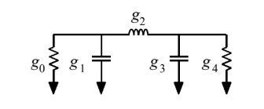 [2]

Figure 3 A low-pass normalised filter

From the figure you can see there are some parameters in the filter g0 , g1 , g2 , g3 and g4 and these parameters hold the values of 1,0.8516,1.1032,0.8516 and 1. Due to the symmetry of the filter we have g0 = g4 and g1 = g3 . now the normalised filter is then transformed into band-pass filter by using the below techniques

 

Figure 4 conversion of inductor

In the above figure 2 Inductor with g is converted or transformed into a series combination of inductor and capacitor whose L&C Values can be calculated using the following formulae.

$$L=\frac{gZ_{0} }{ω_{0}FBW}$$

$$C=\frac{FBW}{Z_{0} ω_{0} g }$$

Capacitor with g is converted or transformed into a parallel combination of inductor and capacitor whose L&C values are calculated using the following formulae.

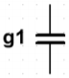 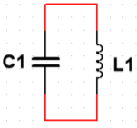

Figure 5 conversion of capacitor

**Formulae**: $$L=\frac{Z_{0} FBW}{g1ω_{0}}$$

$$C=\frac{g1}{Z_{0} ω_{0} FBW}$$

After the transformation all the values of L&C are calculated using the above formulas and a equivalent figure is shown below.

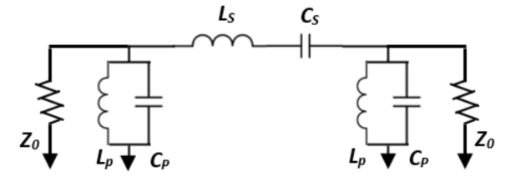 [17]

Figure 6 low-pass to bandpass converted circuit

Also a schematic of the same converted bandpass filter is designed in the ADS software for the simulation. The designed schematic can be seen in the figure below with the calculated L&C values.

**Calculations**:

L1=L3= $\frac{Z_{0} FBW}{g_{1}ω_{0}}= \frac{50*0.08}{0.8516*2*π*1799MHz}$ = 0.4155nH

C1=C3= $\frac{g_{1}}{Z_{0} ω_{0} FBW}= \frac{0.8516}{50*2*π*1799MHz*0.08}$ = $18.8349pF$

L2 = $\frac{gZ_{0} }{ω_{0}FBW}$ = $\frac{1.1032*50}{2*π*1799MHz*0.08}$ = 60.9990 nH

C2 = $\frac{FBW}{Z_{0} ω_{0} g }= \frac{0.08}{50*2*π*1799MHz*1.1032 }$ = 0.1283 pF

**Design in ADS software:**

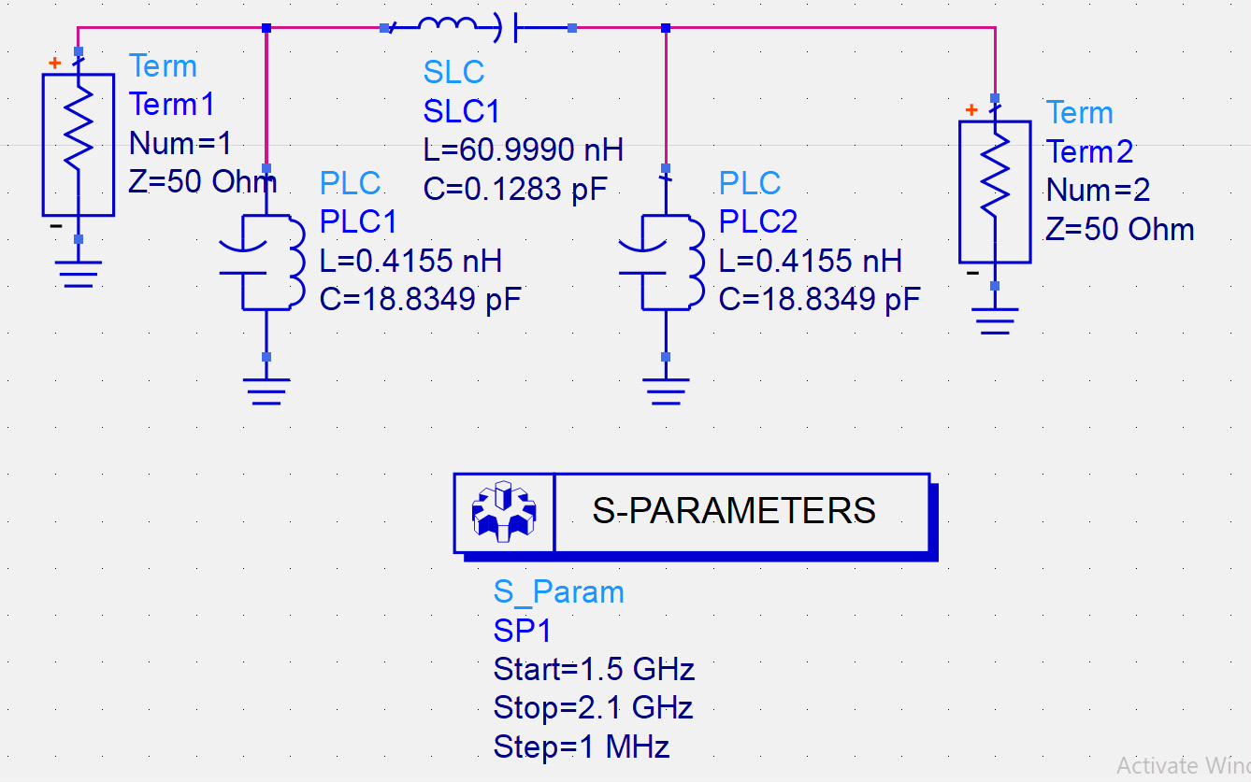

Figure 7 Bandpass filter schematic from ADS

The above figure is the schematic of bandpass filter equivalent to figure 6 and the respected L1, C1, L2 and C2 values are used. S- Parameters of values starting frequency 1.5GHz stop frequency 2.1GHz and a step frequency of 1MHz are also used to obtain the graph**.**

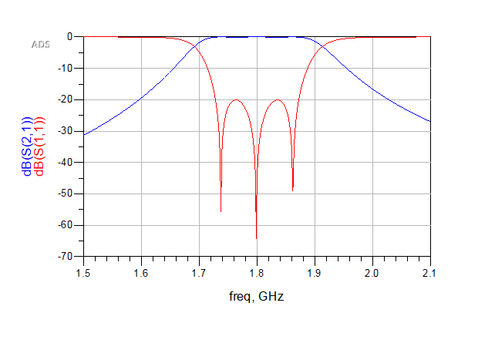

Figure 8 Bandpass filter graph obtained

The above graph is the respected output of bandpass filter and it can be seen that the insertion loss or return loss is exactly 20dB which is exceptional. it shows the filter is very fit to be used

**Theoretical design of j-inverted bandpass filter**:

Secondly, to obtain a dual-band bandpass filter the normalised low pass filter is further converted or transformed into a bandpass filter which contain shunt resonators only. So as to accomplish a double band circuit model, the bandpass channel is intended to have the equivalent pass band swell as the double band channel with a transmission capacity which is equivalent to the consolidated transmission capacity of the two pass bands. This can be accomplished without any problem by scaling every one of the shunt capacitors into shunt resonators utilizing the standard low-go to bandpass change. Since all the shunt capacitors in the below Figure 2 are equivalent to g1, the bandpass channel change is just associated with changing a solitary boundary, i.e., g1, to a shunt of LC resonator. To scale the impedance of the model from the standardized impedance, i.e., g0, to Z0, all the J-inverters have to be partitioned by Z0 as yielded. The bandpass channel circuit model with indistinguishable shunt resonators is appeared in Figure 3.

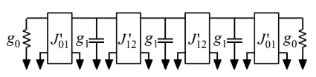 [2]

Figure 9 A normalised low pass filter with shunt reactive components

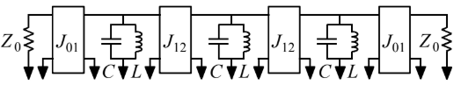 [2]

Figure 10 A filter circuit model with j-inverters and LC resonators

From the above figures you can see that the band pass filter is now consisting of j inverters whose values can be calculated by using the following formulae.

**Shunt parameters calculations**:

J011 = g1

J121 )

J01 J011 / 50 = = 0.02

J12 J121 /50 = = 0.0176

The reactive component (j-inverter) is converted or modelled into a pi-network of capacitors as shown in below figure for easy implementation purpose and the appropriate capacitor values for both the j-inverters are calculated using the following formula.

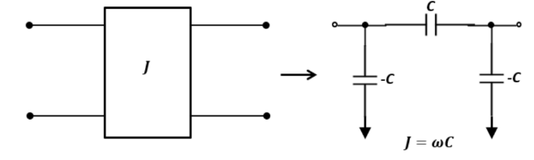 [17]

Figure 11 J –inverter converted into a pi-network of capacitors

= J01 /50 =1.7693pF

= J12 / 50 = = 1.5570pF

Now from the obtained values of shunt parameters and the previously obtained values of L&C for band pass filter an equivalent schematic circuit is designed in the ADS software and simulated for results. The schematic can be seen in the below figure.

**Design in ADS software:**

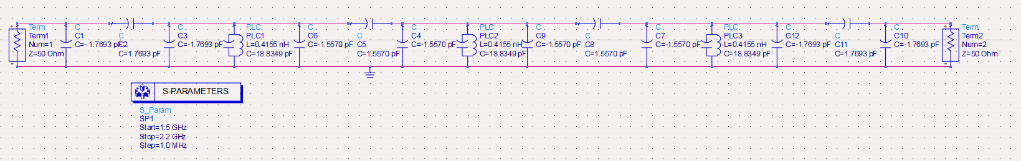

Figure 12 pi network bandpass filter schematic from ADS

The above figure is the equivalent of the figure 8 after following the method of figure 9 converting the j-inverter to pi network. The values of C01 and C12 are used in the schematic to obtain the respected graph.

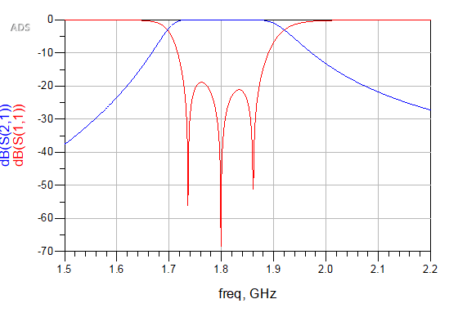

Figure 13 Graph obtained for pi network bandpass filter

The above graph is the outcome of the j-inverted filter and it can be seen that the return loss is very slightly less than 20dB which is to be rectified again.

**Theoretical design of dual-band band-pass filter:**

Once the bandpass filter is designed it can then be converted into the dual-band bandpass filter by coupling each of the shunt resonator with an identical shunt resonator of J111 . The J111 can be obtained from the following formula and calculations.

**Dual-band bandpass filter calculations:**

$k_{11}= \frac{{f_{2}}^{2}- {f_{1}}^{2}}{{f_{2}}^{2}+ {f_{1}}^{2}}$ = $\frac{{2010}^{2}- {1610}^{2}}{{2010}^{2}+ {1610}^{2}}$ = 0.2183

J111  = = = 0.0464

= J111 / = = 4.1049pF

Once it is obtained then it is coupled with the previously designed bandpass filter in the following way as shown in figure.

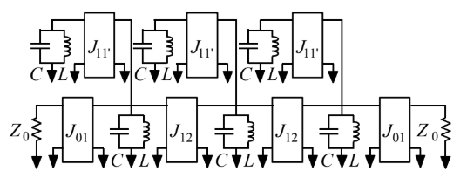

Figure 14 A dual-band bandpass filter [2]

The above figure is the j-inverted bandpass filter coupled with a identical resonator and thus a dual-band bandpass filter is obtained

**Design in ADS software**:

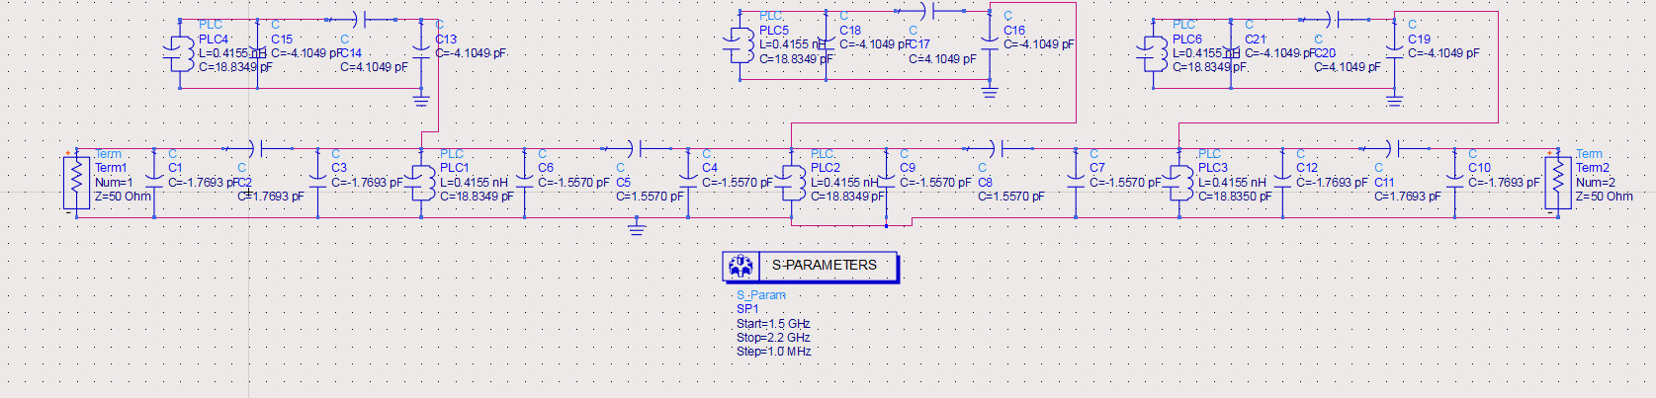

Figure 15 dual-band bandpass filter schematic from ADS

A dual-band bandpass filter schematic diagram designed in ADS software

In the above schematic it can be seen that the j-inverted bandpass filter is now coupled with an identical shunt resonator and thus converted into the dual-band bandpass filter.

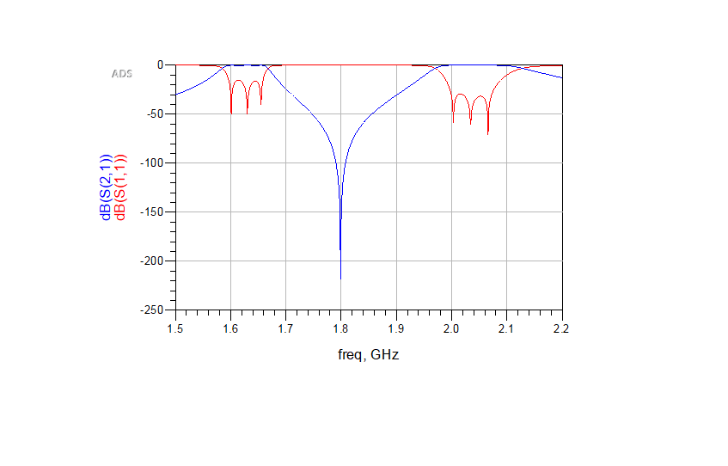

Figure 16 Graph obtained for dual-band bandpass filter

In the above graph the insertion loss or return loss is not adequate when compared to the bandpass filter graph. It is less than 20dB which is to be rectified.

**Chapter 6. Intermediate conclusion**

A model of 3- pole dual-band bandpass filter has been presented. A very detailed design method from the low-pass filter to the dual-band bandpass is also presented. The theoretical design of all the filters was made by using all the respected parameters and equations. These designs were then experimentally verified and the results as graphs were obtained. From the graphs it was observed that the band pass filter and the j-inverted bandpass filter achieved a low insertion loss as expected which is under 20dB. But, the dual-band bandpass filter couldn’t achieve the mark of less than 20dB.

# Chapter 7. References

|  |  |
| --- | --- |
| [1] | L.-C. T. a. C.-W. Hsue, Dual-band bandpass filters using equal-length coupled-serial-shunted lines and Z-transform technique, IEEE Transactions on Microwave Theory and Techniques, vol. 52, no. 4. |
| [2] | A. O. Nwajana and K. Y. S. K. , "A NOVEL MICROSTRIP DUAL-BAND BANDPASS FILTER USING DUAL-MODE SQUARE PATCH RESONATORS," in *Progress in Electromagnetics research*, london, 2013. |
| [3] | W. Wu, L. Zhu, W. J and C. C, "A New Approach to Design Microstrip Wideband Balun Bandpass Filter," in *C. Cai, J. Wang, L. Zhu and W. Wu, "A New Approach to Design Microstrip WidebandIEEE Microwave and Wireless Components Letters*. |
| [4] | Z. L, W. J and H. f, "A New Approach to Design a Microstrip Dual-Mode Balun Bandpass Filter," *IEEE Microwave and Wireless Components Letters,* Vols. vol. 26, no. 4, pp. 252-254, April 2016, doi: 10.1109/LMWC.2016.2538726., April 2016. |
| [5] | A.-T. A, S. K and R. M. G, "Antenna-filter-antenna arrays as a class of bandpass frequency-selective surfaces," *IEEE Transactions on Microwave Theory and Techniques,* Vols. vol. 52, no. 8, pp. 1781-1789, Aug. 2004, doi: 10.1109/TMTT, 2004. |
| [6] | A. N. O, D. A and Y. K.S.K, "Substrate Integrated Waveguide (SIW) Diplexer with Novel Input/Output Coupling and No Separate Junction," *Progress In Electromagnetics Research 8.,* Vols. Vol. 67, 75-84, 2018.. |
| [7] | J.-S. Lim, C.-S. Kim, A. D, Y.-C. Jeong and S. N. , "Design of low-pass filters using defected ground structure," *IEEE Transactions on Microwave Theory and Techniques,* Vols. vol. 53, no. 8, pp. 2539-2545, Aug. 2005, doi: 10.1109/TMTT.2005.8. |
| [8] | J.-S. Y. a. D. A. Jun-Seok Park, "A design of the novel coupled-line bandpass filter using defected ground structure with wide stopband performance," *IEEE Transactions on Microwave Theory and Techniques,* Vols. vol. 50, no. 9, pp. 2037-2043, Sept. 2002. |
| [9] | A. D, I. T, Q. Y and K. J, "A design of the low-pass filter using the novel microstrip defected ground structure," *," in IEEE Transactions on Microwave Theory and Techniques,* Vols. vol. 49, no. 1, pp. 86-93, Jan. 2001, doi: 10.1109. |
| [10] | W. A. E and A. E. A, ""Narrow-Bandpass Waveguide Filters," *A. E. Atia and A. E. Williams, "Narrow-Bandpass WavegIEEE Transactions on Microwave Theory and Techniques,* vol. 20. |
| [11] | K. M. a. T. Felderhoff, ", "Simulation of nonlinear transmission lines by wave digital filter principles," in *IEEE International Symposium on Circuits and Systems*, San diego, 1992. |
| [12] | L. A, H. T and W. R, "A Dual Wideband Filter Design Using Frequency Mapping and Stepped-Impedance Resonators," *IEEE Transactions on Microwave Theory and Techniques,* Vols. vol. 56, no. 12, pp. 2921-2929, Dec. 2008, doi: 10.1109/TMTT.2008.2007357., Dec. 2008. |
| [13] | J. Lee, S. U. Man and Y. In-Bok, "A dual-passband filter of canonical structure for satellite applications," *IEEE Microwave and Wireless Components Letters,* Vols. vol. 14, no. 6, pp. 271-273, doi: 10.1109/LMWC.2004.828010., June 2004. |
| [14] | A.-. R. A, B. A, M. J and O. A, "UWB bandpass filter with wide stopband using lumped coupling capacitors," in *2009 Asia Pacific Microwave Conference*, Singapore, 2009. |
| [15] | I. Kaur, A. verma and T. R. Patel, "performance of lowpass filter using defected ground structure," *International Journal of Engineering Sciences & Emerging Technologies,* vol. 1, 2011. |
| [16] | R. J. Kumud and M. R. , "semicircular microstrip lowpass filter," *ARPN journal of Engineering and Applied sciences,* vol. 3, 2008. |
| [17] | A. O. Nwajana, "Circuit Modelling of Bandpass/Channel Filter with microstrip implementation," *Indonesian Journal of Electrical Engineering and Informatics (IJEEI),* 2010. |
| [18] | H.-W. W. K. S. J.-R. C. R.-Y. Y. a. Y.-K. S. Min-Hang Weng, M.-H. Weng, H.-W. Wu, K. S. J.-R. Chen, R.-Y. Yang and Y.-K. Su, " Anovel triple-band bandpass filter using Multilayer-based substrates for WiMAX," *Min-Hang Weng, Hung-Wei Wu, Kevin Shu, Jau-Rung Chen, Ru-Yuan Yang and Yan-Kuin Su, "A novel triple-band bandpas 2007 European Microwave Conference.* |
| [19] | W. F, G. A, S. C, F. J. P, H. F and J. B. S, "Mobile WiMAX systems: performance and evolution," *IEEE Communications Magazine,* vol. vol. 46, October 2008. |
| [20] | R. D, C. M and T. N, ""Tri-band microstrip bandpass filters for GSM and WiMAX applications," in *2015 4th International Conference on Electrical Engineering (ICEE*, Boumerde. |

**Chapter 8. Gantt chart**

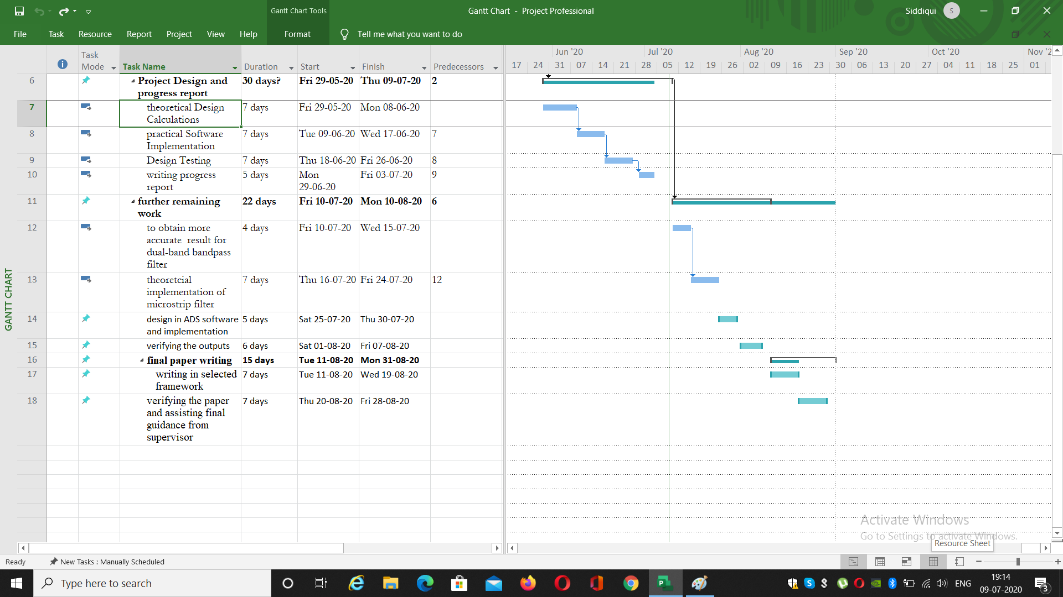

Figure A Gantt chart picture of progress report and future work

In the above Gantt chart the work carried out for the progress report can be seen and also some changes from the last Gantt chart of literature review report can be seen regarding the further remaining work as there is still some work need to be done in terms of the final result of dual-band bandpass filter. It still needs to be verified and obtained for even better result than it was obtained for now.

**Chapter 9. Framework**

**3-POLE DUAL-BAND BANDPASS FILTER FOR WIMAX APPLIACTIONS**

*Written by* **-**Siddiqui Anwar Mohammed (001079524)

*Supervised by* **–** DR. Augustine O. Nwajana

*Abstract*— A design of 3-pole dual-band bandpass filter for WiMAX Applications is proposed and implemented using a very easy and novel method of involving frequency transformations and circuit conversations along with using a center frequency of 1799MHz and a fractional bandwidth of 8% and desires to achieve a the result with 20dB return loss. Initially a normalized low-pass filter is selected which is then converted into dual-band bandpass filter by using j-parameters and the final result is a circuit with admittance inverters and series resonators. The design, implementation and analysis of this paper are carried out by using ADS software and the desired results are obtained and verified.

# INTRODUCTION

First of all, in a Microwave system there are many components present which being amplifiers, filters, antennas etc. out of which the filters are very significant. These filters are basically a two port network very much capable of passing all the transmissions of frequency signals over a pass band and attenuating all the other signals which are over stop-band [1]. Lately, there has been developing enthusiasm for the plan of latent microwave channels. This intrigue is progressively significant with regards to the plan of multi-band channels. Dual band bandpass channel configuration is progressively significant with the ongoing quick development, improvement, what's more, progress in multi-band remote correspondence frameworks. Dual band bandpass channels are additionally valuable for separating a little area of a frequency spectrum inside a wider frequency spectrum [2]. In this paper a design of dual-band bandpass filter will be presented using low-pass to j-inverter conversions. Further work of implementing the Micro-strip [3] [4] for the presented dual-band bandpass filter will be presented. Micro-strip comes under the planar technology which is the major aspect in the microwave field.

A channel, otherwise called bandpass channel (BPF) passes frequencies inside a single band furthermore, attenuates every other signal frequencies outside the band this kind of channel is broadly utilized as the structure hinder in the structure of complex and multi-port circuits and frameworks. A portion of the more mind boggling gadgets that can be framed from BPFs incorporate sifting reception antennas [5], multi-band channels, separating power dividers, diplexers [6], and so on. Signal segments between a lower recurrence cut off, f1 and an upper recurrence limit, f2 while lessening and dismissing all other sign segments that fall outside the f1 and f2 band. A bandpass channel can be shaped by joining a low-pass channel with a high pass channel. Bandpass channels are generally utilized in radio recurrence (RF) front finish of cell radio base station handsets. Its fundamental capacity in the transmitter is to restrict the data transmission of the yield sign to the band allotted for the transmission. By this, the transmitter is kept from meddling with different stations. In the recipient, a bandpass channel licenses signals inside a specific band of frequencies to be gotten and decoded, while halting signals at unwanted frequencies from overcoming. Numerous authors and publishers have published many filters implementing with various aspects like using waveguides, micro-strip, transmission lines and etc.

Manyauthors have presented and published works related to filters like using coupling capacitors, defected ground structure (DGS) [7] [8], micro-strip [9], waveguides [10], transmission lines [11], antennas [5], and many more [12] [13]. In works like coupling capacitors [14], an improved presentation ultra-wideband bandpass channel by utilizing lumped capacitors as an outside coupling to ventured impedance DGS low pass channel structure. The coupling capacitor esteem influences the execution of the channel and controls the lower cut-off frequency. When using techniques like DGS design a low pass filter [15] is proposed, designed and ground is defected or cut in a desired shape which improves its performance. The size of filter is also reduced. The method to calculate the cut-off frequency of the LPF has been developed based on the modelled equivalent inductance and capacitance, which depends on the dimension of the DGS pattern. In addition, the method to determine the size of the DGS pattern, which exactly realizes the required transformed inductance, has been proposed by curve fitting with excellent accuracy. Moving on to micro-strip a half circle micro-strip [16] low pass channel with the sharp dismissal and wide stop band has been structured. The proposed channel configuration depends on the computations of channel parameters from conventional Hi-Lo impedance strategy and is accessible in the writing of micro-strip channel.

 [17]

Figure 1 bandpass filter characteristics

In this paper you can see the design of a dual-band pass filter which initially is from a bandpass filter. So the characteristics of the bandpass filter are presented. In the above figure1 the band pass characteristics can be seen which shows that it allows frequencies of certain bandwidth to pass and attenuates all the other. The fL and fH can be taken for f1 and f2.

**Aim & Objectives**

The main aim of this project is to present design and implement a 3- pole dual-band bandpass filter of return loss 20 dB with a fractional bandwidth of 8% for WiMAX [18] [19] [20] applications. The theoretical design will be carried out first involving a suitable method of multiple conversions and transformations from a normalised low-pass filter to bandpass filter and then bandpass into dual-band bandpass filter. The theoretical design will then be implemented practically using the Agilent ADS (Advanced Design System) software. Some specifications will be set to achieved and the results will be achieved which will then be verified with respect to the specifications. A basic block diagram of the filter can be seen below in the figure and the circuit configurations can be seen in the implementation part further ahead in this paper.

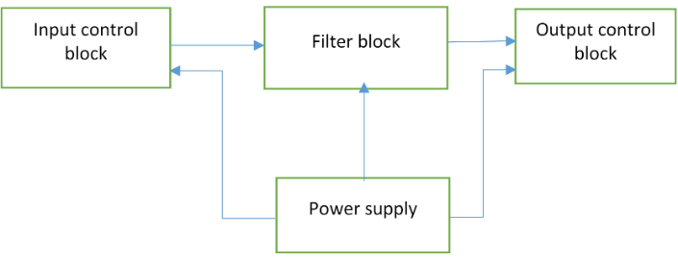

Figure 2 basic block diagram

**Deliverables**

a) Research would be carried out for design and a literature review would be written for that

Design of 3 pole dual band-pass filter in a way easy to understand.

b) A suitable method will then be selected from the literature review to proceed further in to

The design

c) Some objectives would be set to achieve as results

d) Further in to the design implementations and simulations would be performed using ADS

Software.

e) Final results would be displayed indicating the desired specifications are achieved.

References

|  |  |
| --- | --- |
| [1] | L.-C. T. a. C.-W. Hsue, Dual-band bandpass filters using equal-length coupled-serial-shunted lines and Z-transform technique, IEEE Transactions on Microwave Theory and Techniques, vol. 52, no. 4. |
| [2] | A. O. Nwajana and K. Y. S. K. , "A NOVEL MICROSTRIP DUAL-BAND BANDPASS FILTER USING DUAL-MODE SQUARE PATCH RESONATORS," in *Progress in Electromagnetics research*, london, 2013. |
| [3] | W. Wu, L. Zhu, W. J and C. C, "A New Approach to Design Microstrip Wideband Balun Bandpass Filter," in *C. Cai, J. Wang, L. Zhu and W. Wu, "A New Approach to Design Microstrip WidebandIEEE Microwave and Wireless Components Letters*. |
| [4] | Z. L, W. J and H. f, "A New Approach to Design a Microstrip Dual-Mode Balun Bandpass Filter," *IEEE Microwave and Wireless Components Letters,* Vols. vol. 26, no. 4, pp. 252-254, April 2016, doi: 10.1109/LMWC.2016.2538726., April 2016. |
| [5] | A.-T. A, S. K and R. M. G, "Antenna-filter-antenna arrays as a class of bandpass frequency-selective surfaces," *IEEE Transactions on Microwave Theory and Techniques,* Vols. vol. 52, no. 8, pp. 1781-1789, Aug. 2004, doi: 10.1109/TMTT, 2004. |
| [6] | A. N. O, D. A and Y. K.S.K, "Substrate Integrated Waveguide (SIW) Diplexer with Novel Input/Output Coupling and No Separate Junction," *Progress In Electromagnetics Research 8.,* Vols. Vol. 67, 75-84, 2018.. |
| [7] | J.-S. Lim, C.-S. Kim, A. D, Y.-C. Jeong and S. N. , "Design of low-pass filters using defected ground structure," *IEEE Transactions on Microwave Theory and Techniques,* Vols. vol. 53, no. 8, pp. 2539-2545, Aug. 2005, doi: 10.1109/TMTT.2005.8. |
| [8] | J.-S. Y. a. D. A. Jun-Seok Park, "A design of the novel coupled-line bandpass filter using defected ground structure with wide stopband performance," *IEEE Transactions on Microwave Theory and Techniques,* Vols. vol. 50, no. 9, pp. 2037-2043, Sept. 2002. |
| [9] | A. D, I. T, Q. Y and K. J, "A design of the low-pass filter using the novel microstrip defected ground structure," *," in IEEE Transactions on Microwave Theory and Techniques,* Vols. vol. 49, no. 1, pp. 86-93, Jan. 2001, doi: 10.1109. |
| [10] | W. A. E and A. E. A, ""Narrow-Bandpass Waveguide Filters," *A. E. Atia and A. E. Williams, "Narrow-Bandpass WavegIEEE Transactions on Microwave Theory and Techniques,* vol. 20. |
| [11] | K. M. a. T. Felderhoff, ", "Simulation of nonlinear transmission lines by wave digital filter principles," in *IEEE International Symposium on Circuits and Systems*, San diego, 1992. |
| [12] | L. A, H. T and W. R, "A Dual Wideband Filter Design Using Frequency Mapping and Stepped-Impedance Resonators," *IEEE Transactions on Microwave Theory and Techniques,* Vols. vol. 56, no. 12, pp. 2921-2929, Dec. 2008, doi: 10.1109/TMTT.2008.2007357., Dec. 2008. |
| [13] | J. Lee, S. U. Man and Y. In-Bok, "A dual-passband filter of canonical structure for satellite applications," *IEEE Microwave and Wireless Components Letters,* Vols. vol. 14, no. 6, pp. 271-273, doi: 10.1109/LMWC.2004.828010., June 2004. |
| [14] | A.-. R. A, B. A, M. J and O. A, "UWB bandpass filter with wide stopband using lumped coupling capacitors," in *2009 Asia Pacific Microwave Conference*, Singapore, 2009. |
| [15] | I. Kaur, A. verma and T. R. Patel, "performance of lowpass filter using defected ground structure," *International Journal of Engineering Sciences & Emerging Technologies,* vol. 1, 2011. |
| [16] | R. J. Kumud and M. R. , "semicircular microstrip lowpass filter," *ARPN journal of Engineering and Applied sciences,* vol. 3, 2008. |
| [17] | A. O. Nwajana, "Circuit Modelling of Bandpass/Channel Filter with microstrip implementation," *Indonesian Journal of Electrical Engineering and Informatics (IJEEI),* 2010. |
| [18] | H.-W. W. K. S. J.-R. C. R.-Y. Y. a. Y.-K. S. Min-Hang Weng, M.-H. Weng, H.-W. Wu, K. S. J.-R. Chen, R.-Y. Yang and Y.-K. Su, " Anovel triple-band bandpass filter using Multilayer-based substrates for WiMAX," *Min-Hang Weng, Hung-Wei Wu, Kevin Shu, Jau-Rung Chen, Ru-Yuan Yang and Yan-Kuin Su, "A novel triple-band bandpas 2007 European Microwave Conference.* |
| [19] | W. F, G. A, S. C, F. J. P, H. F and J. B. S, "Mobile WiMAX systems: performance and evolution," *IEEE Communications Magazine,* vol. vol. 46, October 2008. |
| [20] | R. D, C. M and T. N, ""Tri-band microstrip bandpass filters for GSM and WiMAX applications," in *2015 4th International Conference on Electrical Engineering (ICEE*, Boumerde. |